**Connect to Oracle Cloud:**

ssh jliu2@129.150.69.91

**Create a folder called Painpill:**

hdfs dfs -mkdir Painpill

**Create folders in Painpill:**

hdfs dfs -mkdir /user/jliu2/Painpill/top15ms

hdfs dfs -mkdir /user/jliu2/Painpill/productms

**In case for having error message (Error: Error while compiling statement: FAILED: RuntimeException…) in hive/beeline:**

hdfs dfs -mkdir tmp

**Give the permission to beeline for edit files/data:**

hdfs dfs -chmod -R o+w .

**Connect to beeline/hive:**

beeline

!connect jdbc:hive2://bigdai-nov-bdcsce-1:2181,bigdai-nov-bdcsce-2:2181,bigdai-nov-bdcsce-3:2181/;serviceDiscoveryMode=zooKeeper;zooKeeperNamespace=hiveserver2?tez.queue.name=interactive bdcsce_admin

create database jliu2;

use jliu2;

**Create main table which will include everything from the data:**

create external table if not exists painpilldata (

reporter_dea_no string, reporter_bus_act string, reporter_name string, reporter_addl_co_info string, reporter_address1 string, reporter_address2 string, reporter_city string, reporter_state string, reporter_zip string, reporter_county string, buyer_dea_no string, buyer_bus_act string, buyer_name string, buyer_addl_co_info string, buyer_address1 string, buyer_address2 string, buyer_city string, buyer_state string, buyer_zip string, buyer_county string, transaction_code string, drug_code string, ndc_no string, drug_name string, quantity int, unit int, action_indicator string, order_form_no string, correction_no string, strength string, transaction_date string, calc_base_wt_in_gm float, dosage_unit int, transaction_id string, product_name string, ingredient_name string, measure string, mme_conversion_factor string, combined_labeler_name string, revised_company_name string, reporter_family string, dos_str int )

ROW FORMAT DELIMITED

FIELDS TERMINATED BY '\t'

STORED AS TEXTFILE

LOCATION '/user/jliu2/Painpill'

TBLPROPERTIES ("skip.header.line.count"="1");

**Using describe and select from function to check the table is created correct:**

describe painpilldata;

select * from painpilldata limit 10;

**Create a Market Share by Product table:**

drop table if exists ms_product;

create table if not exists ms_product

row format delimited fields terminated by '\t'

stored as textfile location '/user/jliu2/Painpill/productms'

as

select product_name, sum(quantity) as quantity

from painpilldata group by product_name order by quantity desc;

**May also use describe and select from function to check the table.**

**Create a table by Top 15 Products’ Market Share:**

create table if not exists top15msp

row format delimited fields terminated by '\t'

stored as textfile location '/user/jliu2/Painpill/top15ms'

as

with top15 as (

select product_name, quantity from ms_product order by quantity desc limit 15)

select * from top15

union all

select "all other" as product_name, sum(quantity) as quantity

from ms_product

where product_name not in (select product_name from top15)

**Exit hive/beeline or open another terminal connect to Oracle Cloud**

**Check the files and folders in top15ms folder:**

hdfs dfs -ls ./Painpill/top15ms

**Rename/Move the files:**

hdfs dfs -mv ./Painpill/top15ms/1/000000_0 ./Painpill/top15ms/1/000000_1

hdfs dfs -mv ./Painpill/top15ms/1/000000_1 ./Painpill/top15ms/000000_1

hdfs dfs -mv ./Painpill/top15ms/2/000000_0 ./Painpill/top15ms/000000_2

**Combine the files as named “top15productmarketshare” and get it to Oracle Cloud:**

hdfs dfs -cat /user/jliu2/Painpill/top15ms/000000_* | hdfs dfs -put - /user/jliu2/Painpill/top15productmarketshare

hdfs dfs -get /user/jliu2/Painpill/top15productmarketshare

**Open a new terminal and Download the file to local pc:**

scp jliu2@129.150.69.91:/home/jliu2/top15productmarketshare top15productmarketshare.csv

**Open Excel and load the data/.csv file to excel file as following:**

**Data🡪 From Text/CSV -> Import**

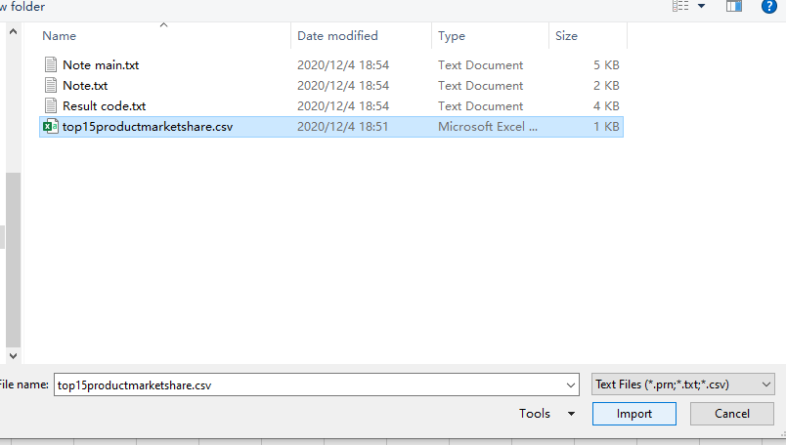

**Leave the default setting or you may change the file origin to Unicode (UTF-8) if you want and Load the data:**

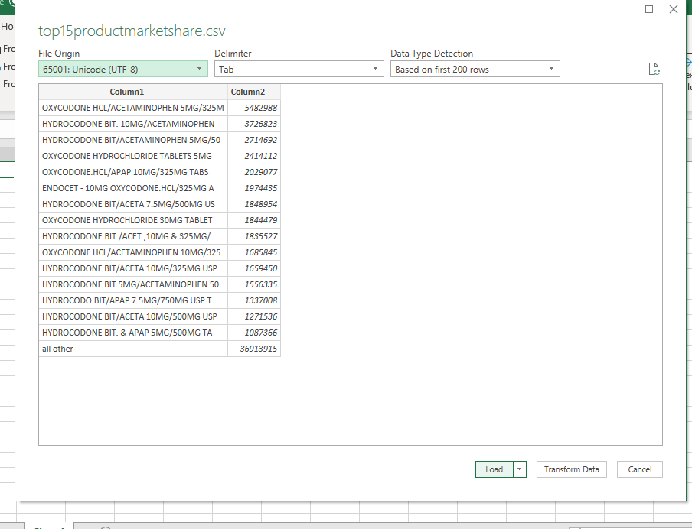

**Changing Column1 and Column2 to “Product Name” and “Quantity”:**

**Select the cell from A2 to B17 and click Insert -> Charts -> 2-D Pie -> Pie:**

**Right Click the Chart area and select Move Chart -> New sheet**

**And Now you can change with the Chart Design and Format option:**

